Sorry it has been so long since we have updated. We have recently been able to create a vJTAG component from scratch and have it be able to take in whatever integer input we want to send it.

A quick rundown of how the vJTAG Megafucntion works. The megafucntion is an overlay of how the actual hardware works (for the most part). The DE0 board uses the MAX II CPLD as part of its JTAG communication, it abides to the IEEE JTAG standard, but has its own instructions, which can be found in the MAX II Documentation (not all of the instructions are listed though). Refer to the link below for the list of IR instructions that are given.

<https://www.dropbox.com/s/srpkrp34b9sdv6r/IR%20Instructions.docx>

Referring to the picture below, for our purposes the only signals that are used form the vJTAG are;

* TCK --Clock of the vJTAG, from most documents read it is 10MHz
* TDI --Serial Data Out
* IR_IN[] --The size of this register is defined when creating the function

--From what we can tell the only use for increasing the size of   
--this register is when you instantiate multiple vJTAG   
--Megafunctions

* VIRTUAL_STATE_CDR --When this goes true then data can be shifted out of the vJTAG
* VIRTUAL_STATE_SDR --When this goes true the vJTAG is in the SHIFT_DR state, we

--use this to indicate when to enable the registers to receive  
--data and/or send data to the TDO.

* VIRTUAL_STATE_UDR --When this goes true the vJTAG is in UPDATE_DR state, we use

--this to let the register that is receiving the data know that all   
 --of the data has been sent out.

* TDO --Serial input to the vJTAG that takes data in.\

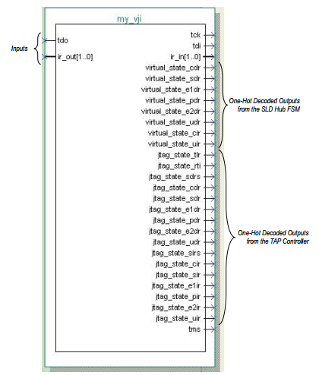

From figuring all of this out and working out how the TCL commands work, we have begun working on the glue logic so that it can be implemented into a verity of situations. The main issue that we are going to face is taking data back into the board, this will require an additional address(es).

We are still building and testing a basic build of an 8 bit bus that has an address register that decodes and activates the addressed register that will take in the next set of information. We are trying to make this a generic as possible and easily implementable.